TCP Protocol Project
• Pe'er Ben Moshe – 211481668 – Group 61305-6
• Yonathan
Table of Contents
Part 1 – Packet Encapsulation and Capture 2
Part 1.a – Creating the CSV file 2
Part 1.b – How the packets are encapsulated? 2
Part 1.c – How the packets are captured? 2
Part 1.d – Transportation in Wireshark 2
Part 1.e – Files 2
Part 2 – Chat Application 3
Part 2.a – General Explanation 3
Part 2.b – Installation and execution instructions 3
Part 2.c – I/O Examples 3
Part 2.d – Transportation Analysis 3
Part 2.e – Files 3
Part 3 – AI Use 4
Part 3.a – Why we used AI 4
Part 3.b – Prompt examples 4

Part 1 – Packet Encapsulation and Capture

Part 1.a – Creating the CSV file
The CSV file was created using AI.
We used the fields and the line example from the project guide and asked the AI to generate a CSV file of HTTP messages, based on the fields and example we gave.
The AI had some difficulties creating a file, so we took the text and pasted it in Notepad, then saved it as .csv file.

Part 1.b – How the packets are encapsulated?
The Jupyter notebook is trying to mock packet encapsulation, through a flow of several functions.
First, we will list the functions and explain each, then we'll explain about the flow itself.
Function – checksum:
This function calculates the checksum of a packet, by receiving some data as a parameter. This is important because without a correct checksum, a packet will be dropped.
Function – build_ip_header:
This function builds an IP header manually.
It defines details such as version, protocol (of transport layer), source, destination… Then builds the header with a checksum=0, only to calculate the checksum of this header and finally builds the header with the correct checksum and returning it.
Function – build_tcp_header:
This function acts similarly to the IP header builder (logically), defining the details of the TCP header, building a header with checksum=0, calculating the real checksum and finally building the header and returning it.
Function – encapsulate:
This function joins and returns the IP header, TCP header, and the message (from the CSV file).
The headers are received inside the function, by calling the "build header" functions (explained above), the message data is received from the "send" function that accepts the encoded data (and is called each time we wish to send a message)
How everything is integrated – RawTcpTransport:
This class creates an object based on a unique 4 tuple (source IP, destination IP, source port, destination port).
The object is built according to the OS as well (Windows/Linux).
Finally, when wishing to send a message, we use the send function from the RawTcpTransport object, this function acts according to the OS;
If it's Linux/Mac – calling encapsulate and then sending the packet.
If it's Windows – using Scapy library in order to build the packet, and sending over the Loopback interface. Notice that in this option, the function encapsulate is not called (hence the build header functions are not called as well) – which means that Scapy constructs the IP and TCP headers, rather than using the function from the notebook.

Part 1.c – How the packets are captured?
In our setup (Windows), the messages are sent using Scapy library, and Npcap loopback interface.
When sending a message, Scapy hands the data to the Npcap driver, which send the data over the network (or in this case, from one part of the RAM to another – because we use loopback interface), and a copy of the data is sent to Wireshark.
Finally, Wireshark decodes the data into readable text so we can interact and analyze it.

Part 1.d – Transportation in Wireshark
At first, we thought that we have some problem with the CSV files, with the notebook or with our network settings – as the Wireshark pcap was full of retransmissions (from client to server) and resets (from server to client).
We tried changing stuff, debugging areas in the notebook, even altering firewall settings…
Then, after progressing with the lectures (and some help from AI), we understood what was happening there.
Client → server:
The first record is "fine" – no visible errors or warnings in Wireshark.
Every record after that is flagged as retransmission, this is because the sequence number is not advanced (nor acked) so Wireshark sees it as a retransmission of the same message.
This happens because Scapy is not altering the sequence number.
Filter used: tcp.dstport == 12345
Server → client:
All the records are flagged with reset (RST).
This happens because we never initiated a connection between the client and the server.
The OS kernel receives the messages (as we send in loopback), and says "I don't have an established connection for this 4-tuple, sending a reset!".
Basically, the whole notebook is working "stateless" – it just sends data without connecting to anything, while TCP protocol is "stateful" – requires a handshake between the client and server before sending data.
Filter used: tcp.srcport == 12345

Other than that, we can see more details inside the records:
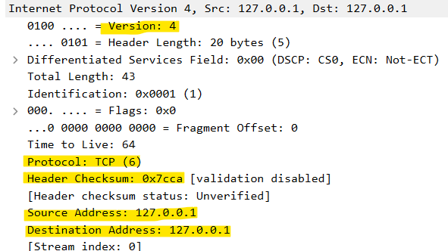
• Same source and destination IP (loopback address)
• IPv4
• TCP protocol
• Checksum calculated

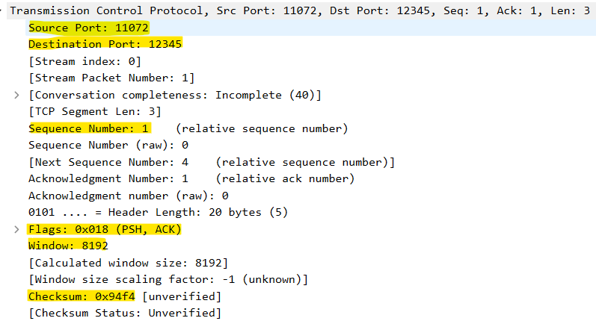
• Correct destination (server) port
• Source port is a random number that was set when the RawTcpTransport object was created
• The sequence number (which does not advance)
• The active flags (PUSH, ACK)
• Window size
• Checksum

Part 1.e – Files
• CSV file
• Jupyter notebook
• Wireshark pcap

Part 2 – Chat Application

Part 2.a – General Explanation

Part 2.b – Installation and execution instructions

Part 2.c – I/O Examples

Part 2.d – Transportation Analysis

Part 2.e – Files

Part 3 – AI Use

Part 3.a – Why we used AI

Part 3.b – Prompt examples

